**PRACTICAL-2**

Assume JK Enterprises organization wants to start with new application development. There are four members in a group. For better workflow, they have decided to use IBM Security Identity Manager (ISIM) for handling the identity of each individual. Organization has decided to use IBM Security Directory Server (SDS) feature to add users under each instance and make copies/replicas of instances to improve performance, availability and reliability.

**LDAP**

**The *Lightweight Directory Access Protocol* (*LDAP*) is a set of open protocols used to access centrally stored information over a network. It is based on the *X.500* standard for directory sharing, but is less complex and resource-intensive. For this reason, LDAP is sometimes referred to as "*X.500 Lite*." The X.500 standard is a directory that contains hierarchical and categorized information, which could include information such as names, addresses, and phone numbers.**

**Major functionality in scenario:**

* Adding Suffix JKE
* Adding User for each instance

**Steps:**

1. Listing server instances

/opt/ibm/ldap/V6.4/sbin/idsilist –a

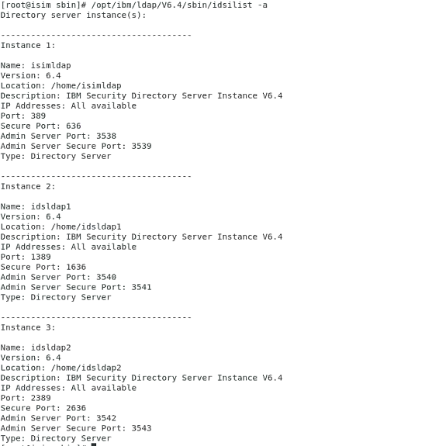

1. Adding Suffix

/opt/ibm/ldap/V6.4/sbin/idscfgsuf -I idsldap1 -s "o=jke" -n

/opt/ibm/ldap/V6.4/sbin/idscfgsuf -I idsldap2 -s "o=jke" -n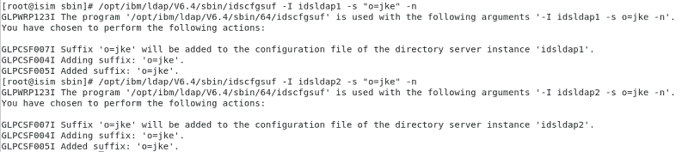

1. Starting Server Instances

/opt/ibm/ldap/V6.4/sbin/ibmslapd –I idsldap1 –n –t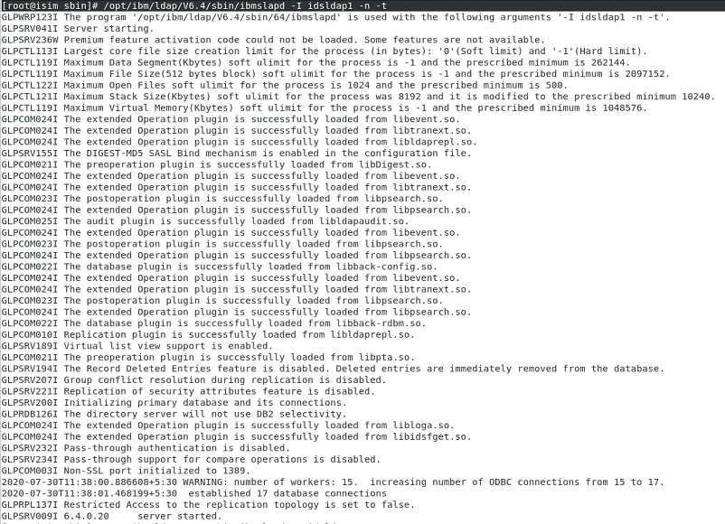/opt/ibm/ldap/V6.4/sbin/ibmslapd –I idsldap2 –n –t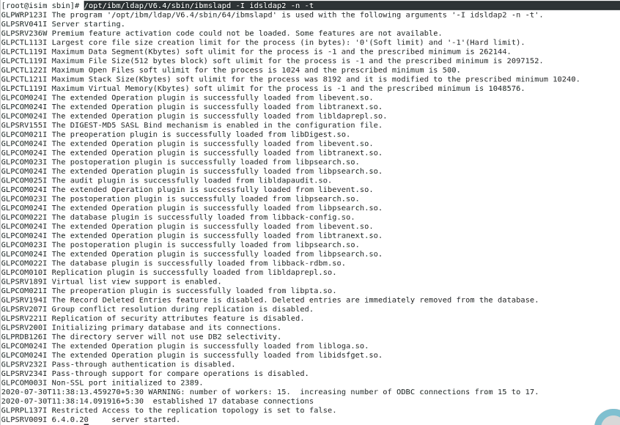

1. Verifying entries in console

* 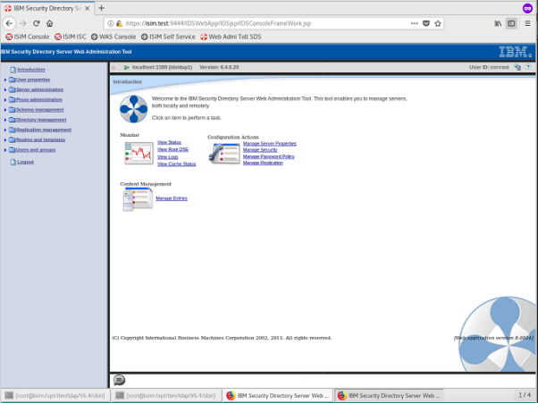

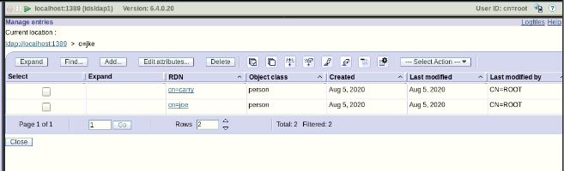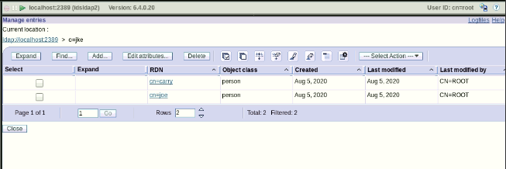

1. Adding users through .ldif file

* cd /classfiles
* gedit User2.ldif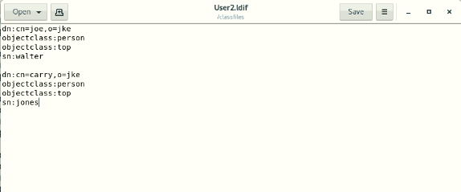

1. Adding users through ldap browser

* Click on New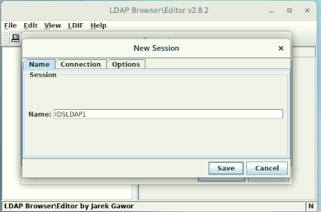
* Go on connection tab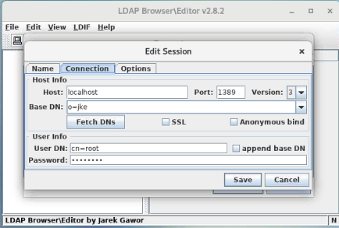
* Click on Save and Connect to IDSLDAP1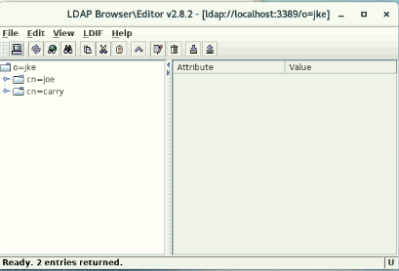
* Import file

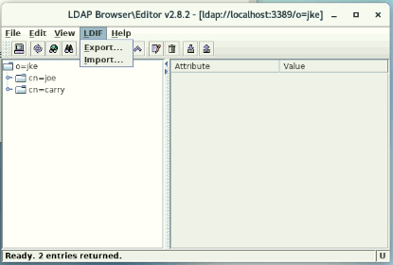

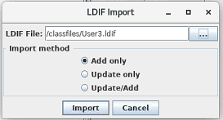

* Verify User entries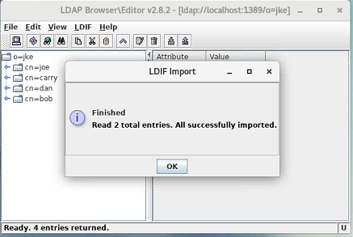
* Similarly for ldap2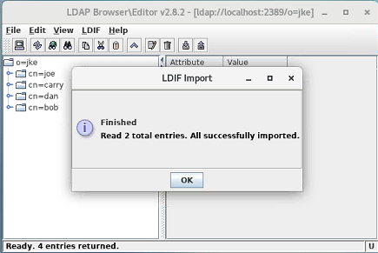

**Conclusion:**

* While adding a suffix ,server instances should be stopped.
* And while adding users server instances should be running.